***Some Demo My E-com…. Project How Look Its:-***

***First user View of home page:-***

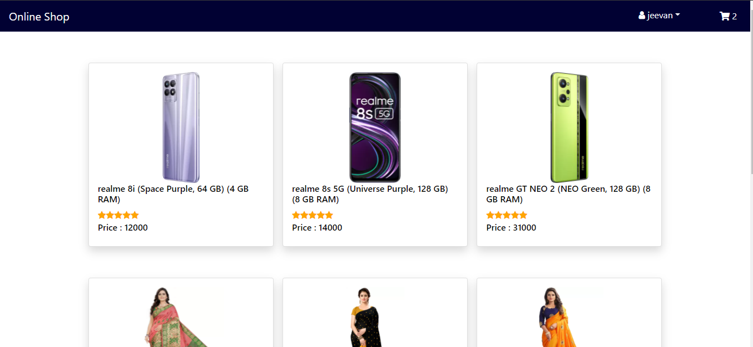

***Details views of Products:-***

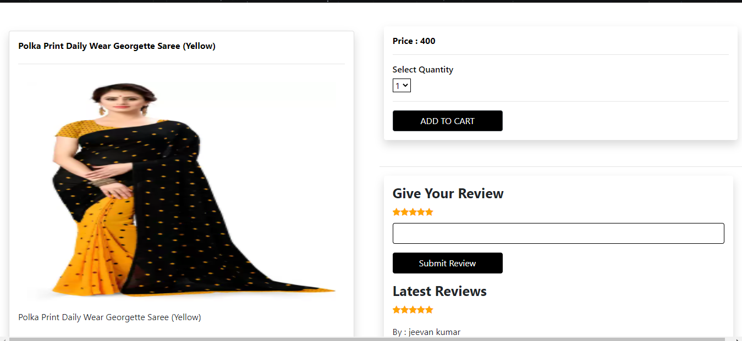

***Check Out page Look Like :-***

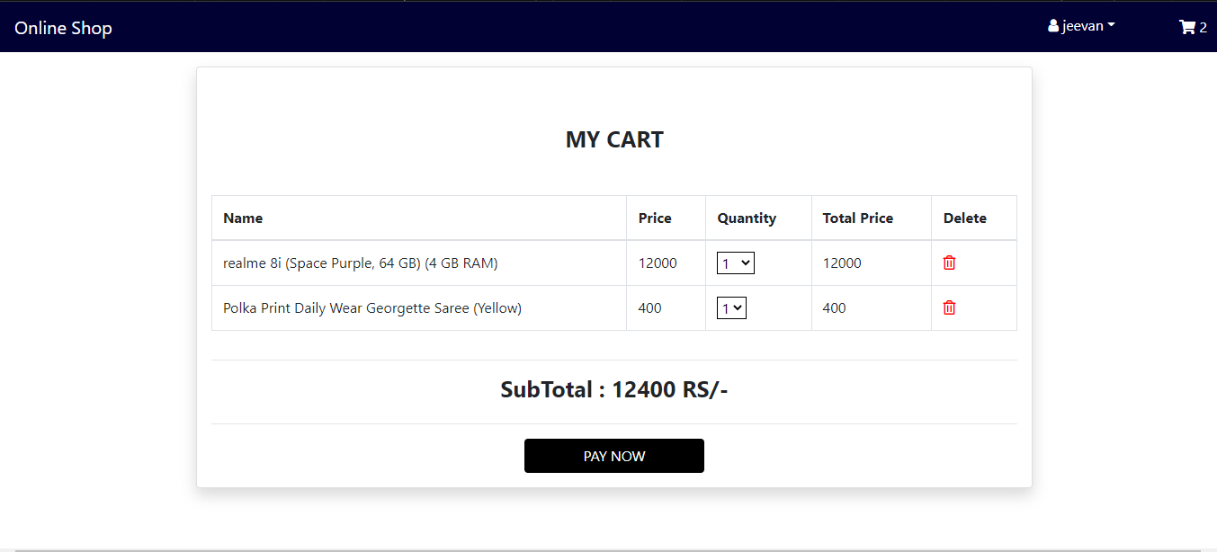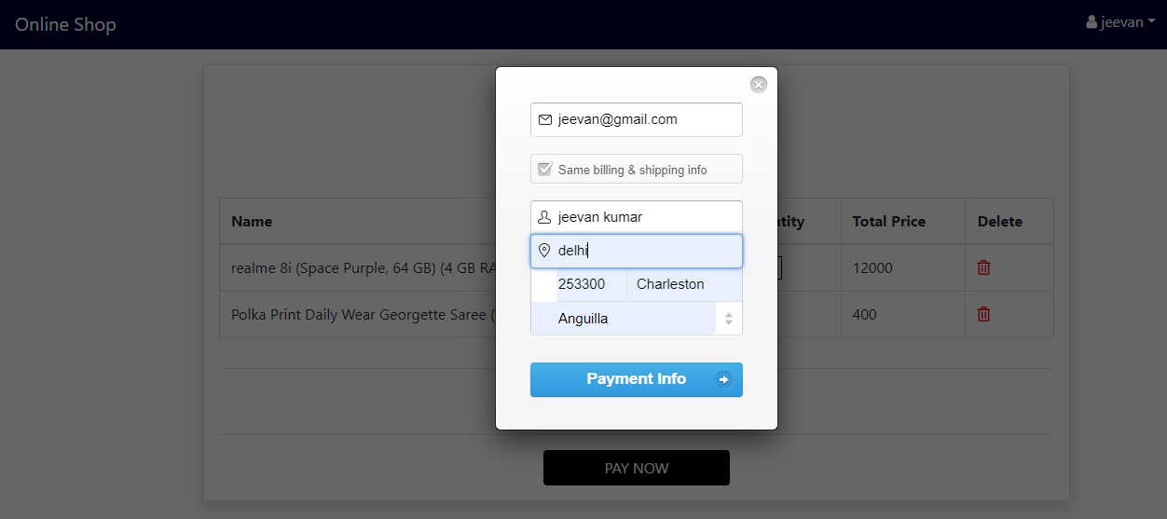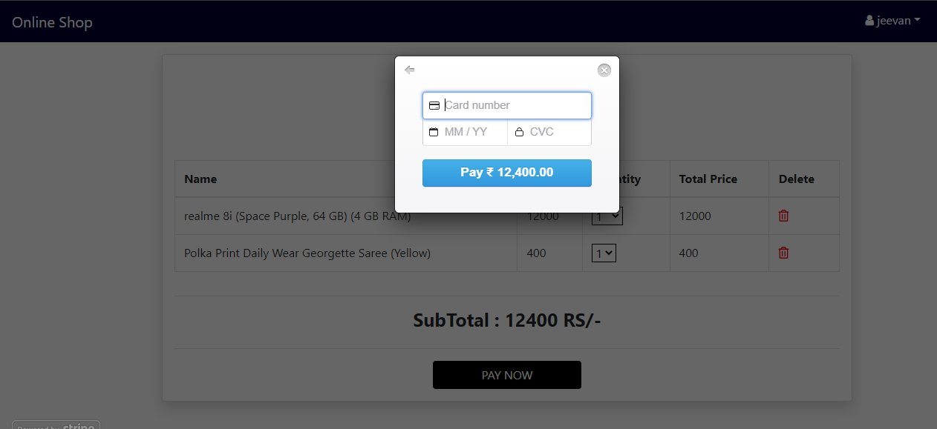

***User Register page:-***

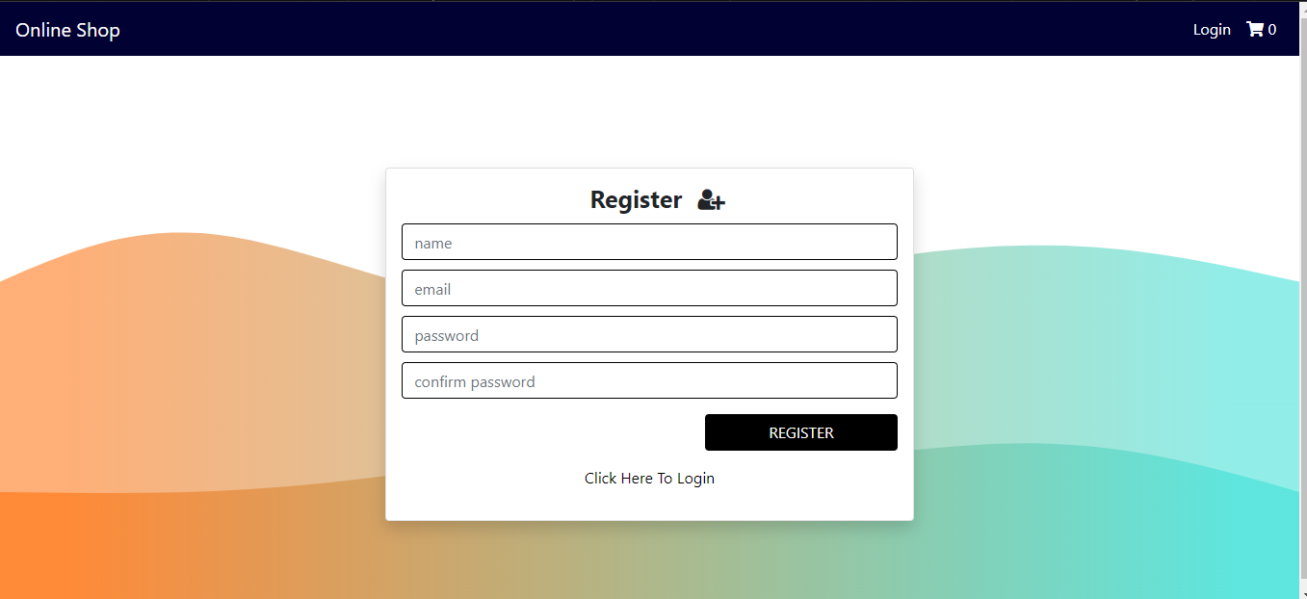

***User Login Page:-***

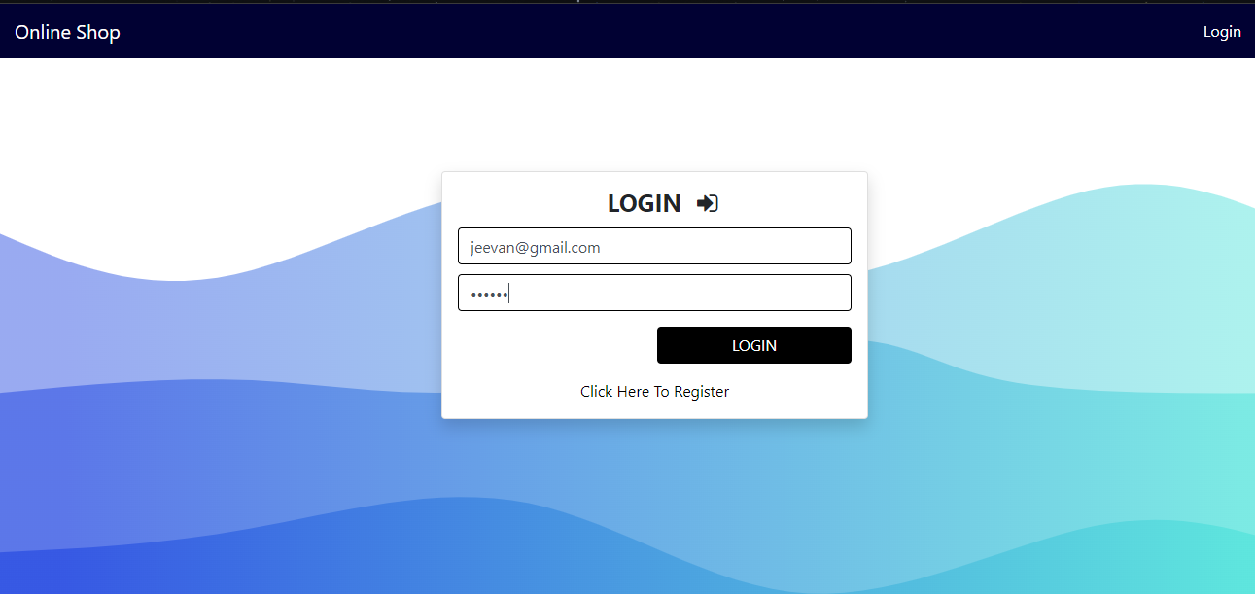

***Admin panel look like:-***

***User List:-***

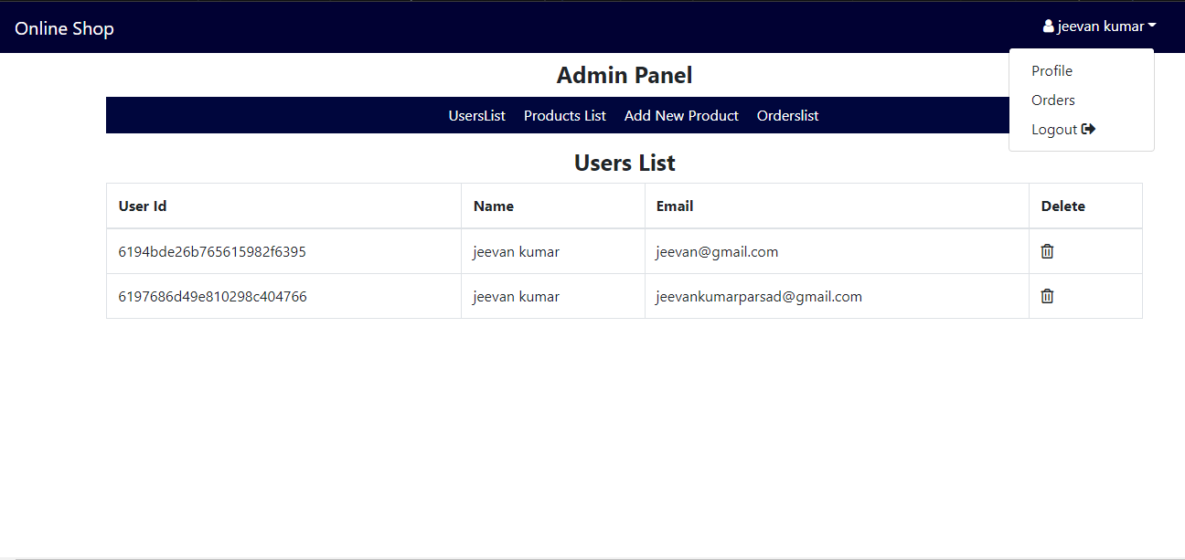

***Product list (CRUD) Page:-***

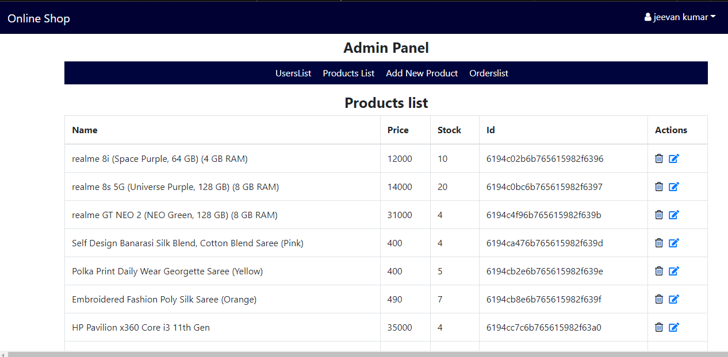

***Add new products:-***

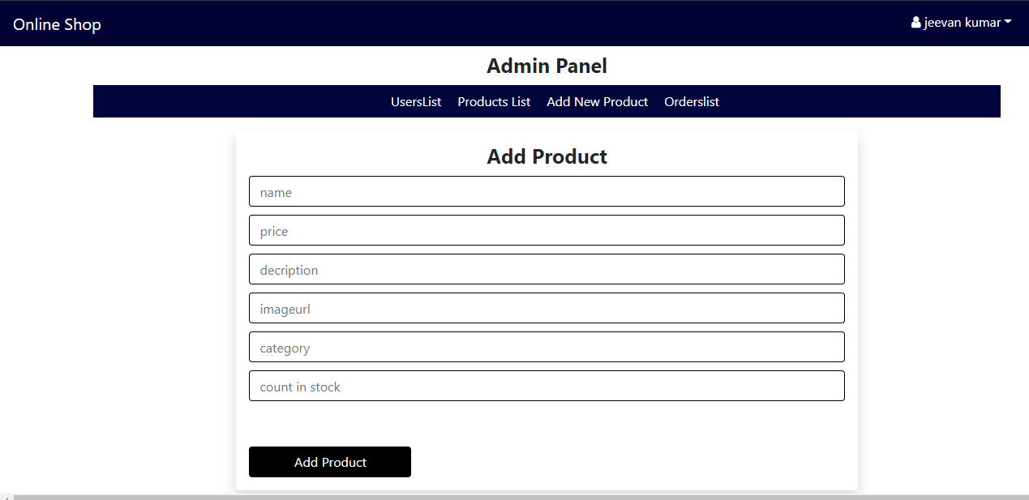

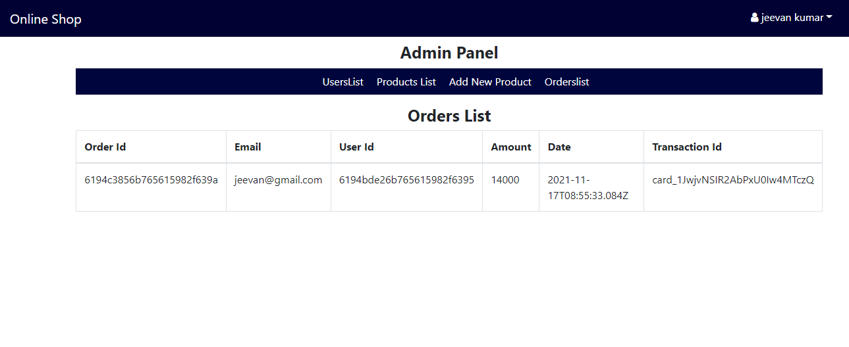

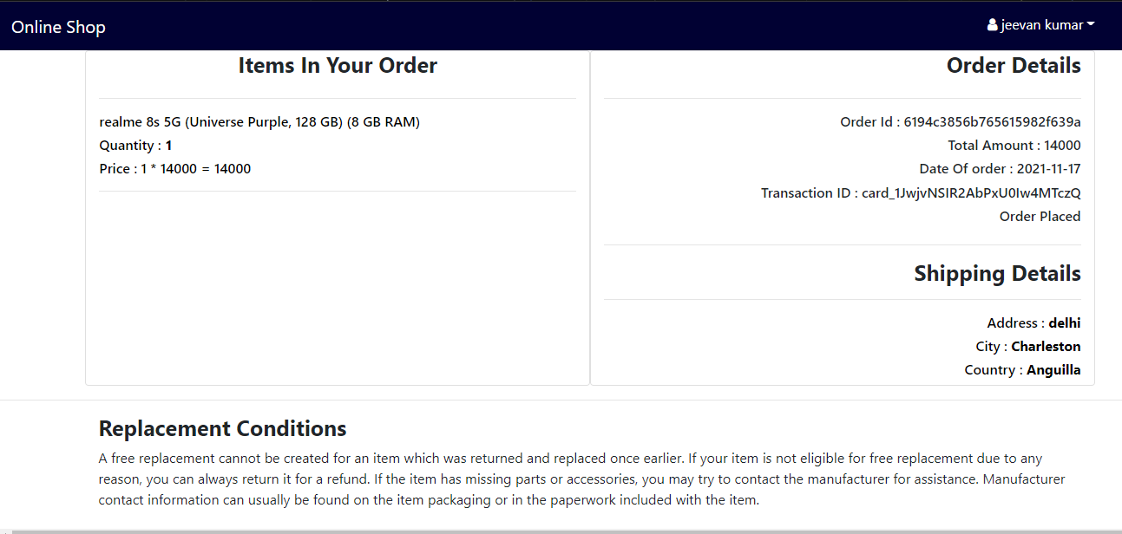

***Submitted By :- jeevan kumar***

***From :- Riya mam ji & Prasad Sir***

***Thanks & Regards***

***Jeevan kumar***

***Mob:- 6396173402***